2011 H LIDAY GIFT GUIDE
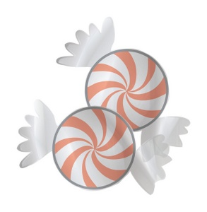
FOR
F DIES
A LOCAL SHOPPING GUIDE FOR THE FOOD ENTHUSIAST

PRESENTED BY: THEPALATEPRINCESS.COM
Santa’s making a list, he’s checking it twice—but does he know what to bring the good little foodie? Just as hardcore gamers eagerly await the release of a new video game and tech geeks clamor for the latest gadget, food lovers salivate over expensive enamelware, swoon over kitchen tools and wish for editorial-worthy dream kitchens. This year, you don’t have to look any further than your local specialty stores, farmers markets and gourmet shops for amazing finds for the foodie in your life.
GOURMET & SPECIALTY FOODS
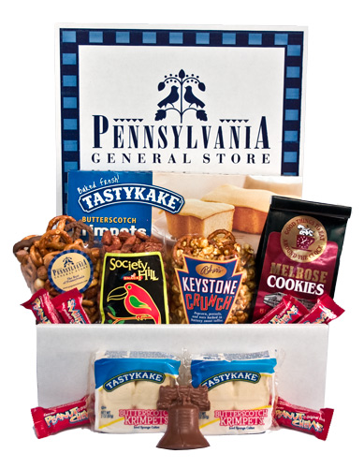 | 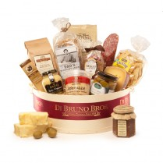
Philadelphia Care Package - $39.99  Pennsylvania General Store  228 Krams Ave.  Philadelphia, PA 19127  (215) 508-1881 | Website | Item  What better way to send a little piece of home to the food lover who can’t be home for the holidays? It’s filled with local delicacies like Krimpets, Melrose Diner butter cookies, and Asher’s crunch. | Cheesebox Favoloso - $149.99  Di Bruno Bros. (Various locations)  Item available online only  (888) 322-4337 | Website | Item  With a price tag of nearly $150, this gift basket—overflowing with a variety of delicious gourmet treats that have come to define the popular Philadelphia specialty shop—is for the serious gourmand whose palate craves the finer things in life.

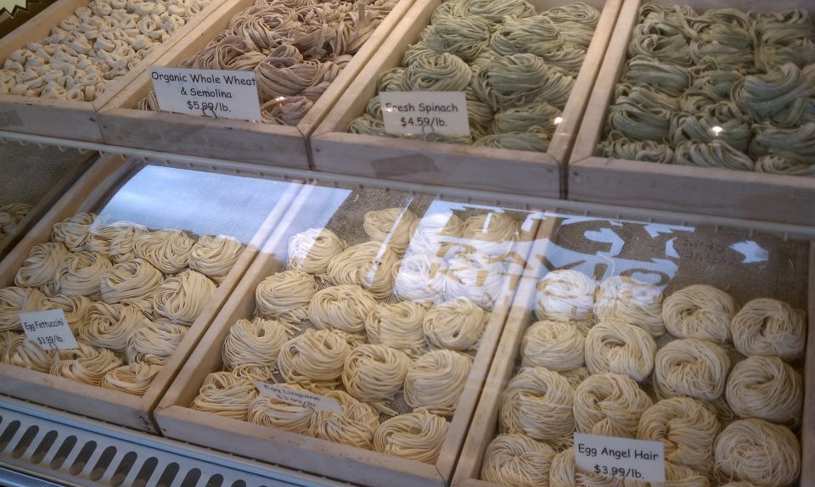
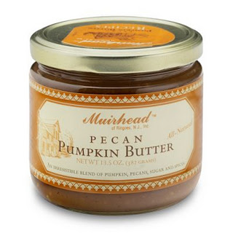
Pecan Pumpkin Butter - $6.75  Muirhead of Ringoes NJ, LLC  Item available at various resellers  (908) 782-7803 | Website | Item  Providing a sweet deviation from traditional apple butter, pecans and the familiar holiday taste of pumpkin come together in this yummy spread. Muirhead produces an array of butters, jellies, chutneys and mustards—great for slathering on just about anything! | Handmade Pasta & Ravioli – Various prices  Lucy’s Ravioli Kitchen & Market  830 State Rd. (Route 206)  Princeton, NJ 08540  (609) 924-6881 | Website  Tucked away in a tiny strip mall, Lucy’s specializes in natural, handmade pastas, ravioli and other Italian eats. The dedicated foodie and home cook will delight in hard-to-find items like piment d’espelette and giant cans of San Marzano tomatoes.

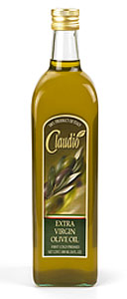
Claudio Extra Virgin Olive Oil - $24.99
Claudio Specialty Foods
924-26 South 9th St.
Philadelphia, PA 19147
(215) 627-1873 | Website | Item
True foodies know that a good-quality olive oil can transform a dish and this fruity, fragrant oil is light enough to stir into a sauce or drizzle on drizzle on salad greens.

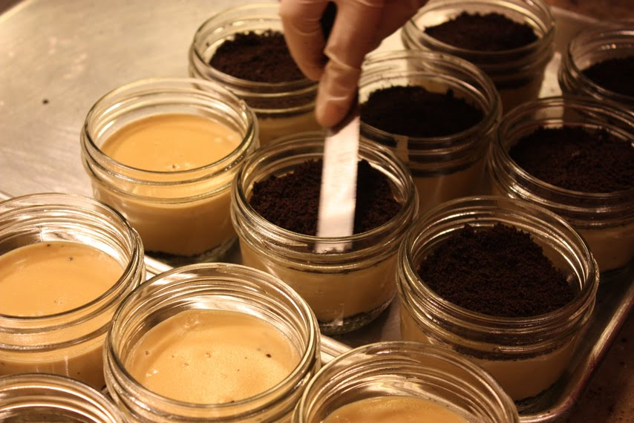

6-pack Salted Caramel Budino - $45
Barbuzzo
110 S. 13th St.
Philadelphia, PA 19107
(215) 546-9300 | Website | Item
The salted caramel budino (Italian egg pudding) from relative newcomer Barbuzzo may, quite arguably, be the best dessert in the city. If Helen of Troy was the face that launched a thousand ships, this salty and sweet treat is the dessert that set the local food world abuzz. The food lover in your life will thank you—that is, if you don’t keep it for yourself.
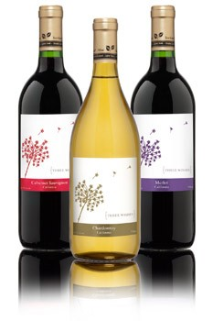 | Three Wishes Vineyards (Merlot, Chardonnay, Cabernet Sauvignon) - $2.99  Sold exclusively at Whole Foods Market  Website | Item  Three Wishes is Whole Foods’ effort to trump Trader Joe’s popular $1.99 Charles Shaw wine (affectionately known as ‘Two-Buck Chuck’) and, while some may scoff at the shockingly low price tag, the wine itself isn’t bad at all. It’s a great idea to stock up on this wine to hand out as gifts at your holiday dinner party.
GADGETS, TOOLS, BOOKS & MORE
OXO Good Grips Rotary Egg Beater - $19.99  Fante’s Kitchen Shop  1006 S. 9th St.  Philadelphia, PA 19147  (215) 922-5557 | Website | Item  Everything old is new again! OXO, the kitchen gadget titan, has released an updated version of the old-school rotary whisk just in time for the holidays. Fante’s, located in the Italian Market section of South Philadelphia, carries it and just about every conceivable kitchen gadget, tool and small appliance there is—a true cook’s heaven.  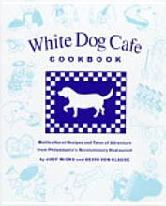 | 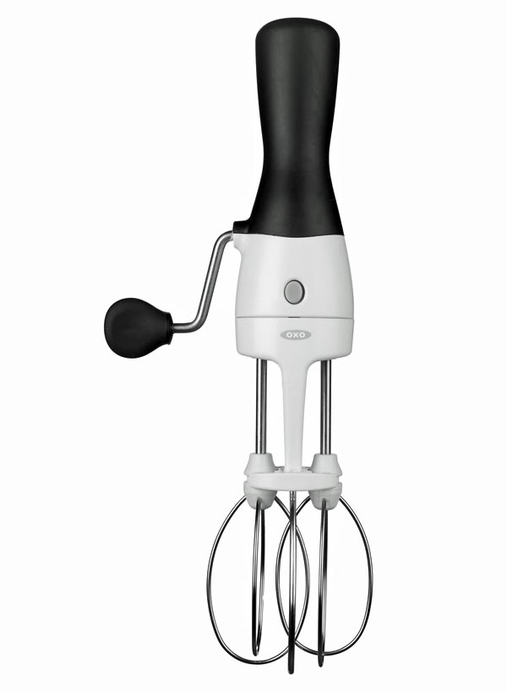
White Dog Cafe Cookbook - $29.95  The Cookbook Stall (Reading Terminal Market)  12th & Filbert Sts.  Philadelphia, PA 19107  The Cookbook Stall has everything from the popular to the obscure. This is a great cookbook for those interested in recreating some of the dishes from this popular sustainable eatery. | J.K. Adams Bread and Oil Plank - $42  Pro Kitchen Gear  4021 E. Kennett Pike  Greenville, Delaware 19807  (302) 478-1020 | Website | Item  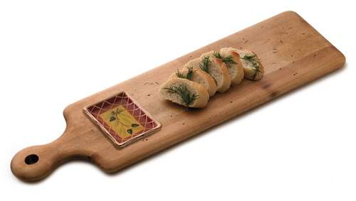  This maple wood board has a built-in stoneware well for the purpose of holding dipping oil. It can also double well as a cheese board—aren’t multi-purpose kitchen tools great?
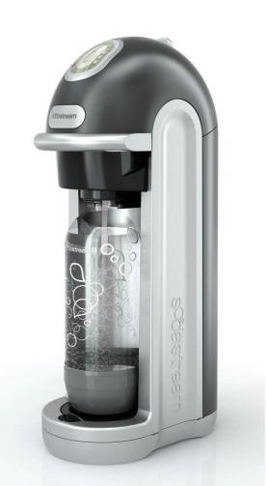 | Sodastream - $89.95  Kitchen Kaboodle  104 W. Beaver Ave.  State College, PA 16801  (814) 237-8052 | Website | Item  This soda-making machine is perfect for foodies who fancy themselves chemists as well. It turns boring tap water into sparkling water in minutes! Pre-packaged soda mixes can be purchased, but half the fun of using the Sodastream is concocting your own mixer recipes.

Set of Vintage Glass Ball Jars (3) - $30  The Little Apple Store  4353 Main St.  Manayunk, PA  (267) 335-4968 | Website | Item  Ask any home cook what they most crave in their kitchens and they will tell you more storage. With an authentic aged patina, these vintage Ball jars have that coveted “reclaimed” look that’s hot right now. | 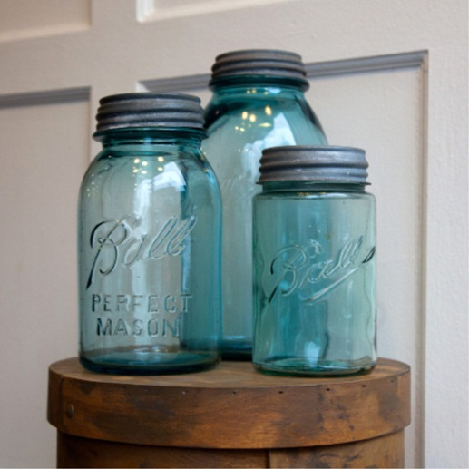
ChefN Garlic Zoom Garlic Chopper - $9.99  Le Gourmet Chef  311 Stanley K. Tanger Blvd.  Lancaster, PA 17602  (267) 335-4968 | Website | Item  As strange as it looks, this little contraption makes chopping garlic fun and easy. Simply throw in some peeled garlic cloves and roll the device a few times and—presto—you’ve got chopped garlic! This makes a great stocking stuffer for gadget-loving cooks. | 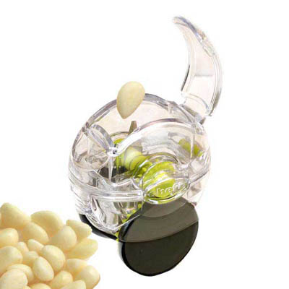

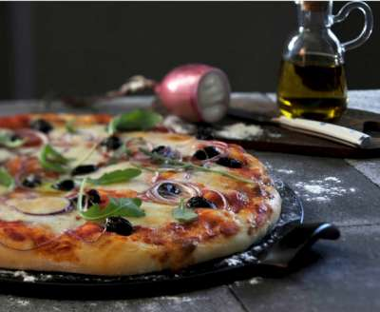 | Pizza Stone - $37.50  Emile Henry Factory Outlet  802 Centerpoint Blvd.  New Castle, DE 19720  (302) 326-4800 | Website | Item  This pizza stone will change your life. Seriously. Crust is to pizza what bread is to a sandwich and this stone will allow you to get the all-important perfectly crispy crust. It can go into the oven or on the outdoor grill and is great for making artisanal flatbreads, too.

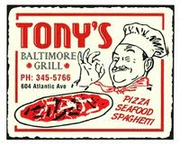 | Vintage Restaurant T-Shirts  Retro Philly  (855)738-7655 | Website | Item  Retro Philly, the area’s leading vintage clothing merchandiser, has a collection called ‘Neat Eats’ that features t-shirts with logos from favorite area eateries of today and yesteryear.

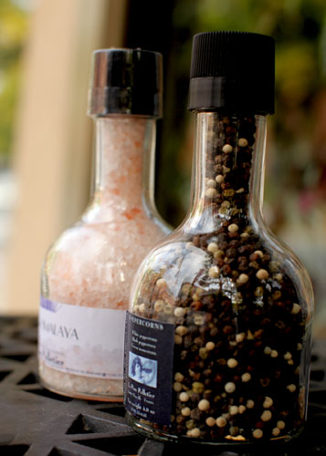 | Pink Himalayan Salt & Mixed Peppercorns (Set) - $48  Talula’s Table  102 West State St.  Kennett Square, PA 19348  (610) 444-8255 | Website | Item  Talula’s is the go-to gourmet food shop and this salt and pepper set is an essential in any kitchen.

COOKING CLASSES, FOOD TOURS & EVENTS
Believe it or not, sometimes foodies actually leave their own kitchens. Ironically, it’s usually to attend some food-related event. A true food enthusiast is a social creature—we love to mix and mingle with others who share our love of food and, with the growing popularity of ‘food tourism’, there’s never been a better time to take a fun hands-on cooking class or a food tour to discover regional treasures and the food artisans behind some of the best local eats.

Bucks County Food Tours (Guided van tour through scenic PA where patrons meet and greet local food artisans)  Telephone: (215) 598-3979 | Website | Chef’s Haven (Cooking class)  1304 Old Lancaster Pike  Hockessin, DE 19707  Telephone: (302) 234-2040 | Website
COOK (Collaborative demo kitchen)  253 South 20th St.  Philadelphia, PA 19103  Telephone: (215) 735-2665 | Website | Annual Emile Henry Factory Outlet Sale (coupon below)  800 Centerpoint Blvd.  New Castle, DE 19720  (302) 326-4800 | Website
Madame Fromage (Cheese classes & private tastings)  Philadelphia, PA  Website | Viking Cooking School (locations in NJ as well)  1 Town Place, Suite 100  Bryn Mawr, PA 19010  Telephone: (610) 526-9020 | Website

Clip this ad, bring it to the Emile Henry sale & get a FREE gift!

EAT LOCAL | BUY LOCAL | SUPPORT SMALL BUSINESSES

